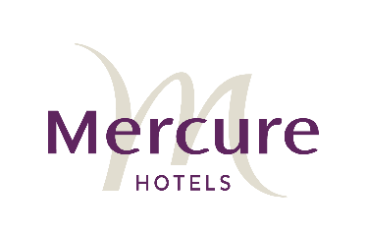
Media Release
11 April 2019
All aboard Platform 818 Restaurant & Bar for a palatable excursion of regional NSW
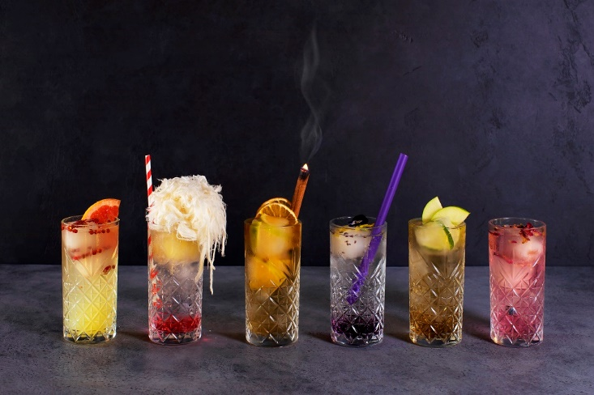
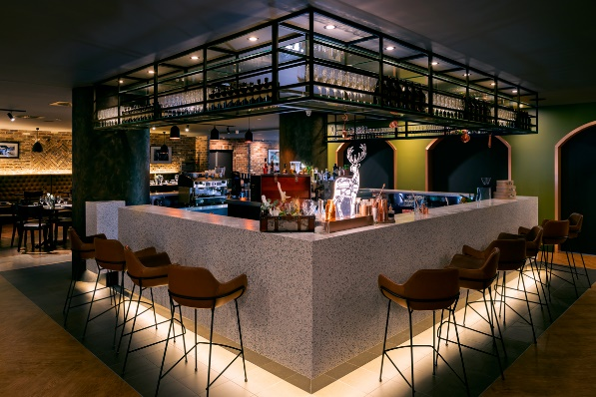
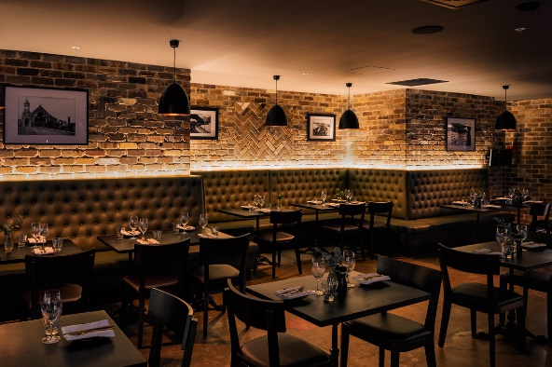
New 200-seat restaurant opens at Mercure Sydney

For high resolution images of Platform 818 Restaurant & Bar, click here.
With the construction of George Street’s light rail project nearing completion, many of Sydney’s best restaurants are jostling for prime position. Head downtown to the Sydney Central end of George Street to experience Platform 818 Restaurant & Bar, a brand new 200-seat restaurant located within Mercure Sydney, which opens today.
Platform 818’s restaurant concept takes inspiration from its prime location, conveniently located opposite Sydney’s historic Central Station. When it first opened in 1855, Sydney’s Central Station was a simple wooden platform, nothing more than a corrugated iron shed. Platform 818 have taken some of this rustic inspiration for its own industrial interior and the menu draws on the fact that directly below the hotel lies the now unused original Goods Line Tunnel that connected Sydney Rail Yard and the Sydney-Parramatta railway line to the shipping port of Darling Harbour.
Even the produce served at Platform 818 Restaurant & Bar has a great story to tell, with hero items on the menu sourced from railway towns along the New South Wales goods line that once would have travelled into Sydney’s Central Station via the Goods Line Tunnel.
With a modern take on classic Australian dishes, executive chef, Simon Harrison and sous chef, Richard Batchelor’s menu features items such as the sticky BBQ pressed Riverina brisket ($15), and pulled Break Out River lamb shoulder tart ($15) sourced from Cowra Lamb in the Riverina. With a stellar line up of grilled cuts on the menu from regional NSW, try the Riverina angus sirloin ($38), Murray Basin pork cutlet ($35) or for the pièce de résistance savour the Grange plus scotch fillet ($46).
The restaurant’s signature drink is the highball cocktail, inspired by the practice of serving beverages in tall highball glasses on steam trains. Carefully crafted cocktails are fashioned by Platform 818’s resident Mixologist, using bespoke PS40 soda served with flavour-infused blocks of ice, beautifully decorated in highball glassware. With equally creative names, the favourites are sure to be Tokyo to Osaka, Platform 9¾, Gare De Grenoble and Spring Bluff Station. Not to miss is the inimitable whisky terrarium experience with bespoke crafted whisky tastefully paired with hand-crafted chocolate truffle.
Platform 818’s all-Australian wine list features the lesser known and the rising heroes, curated to highlight the diversity and complexity that is the world of Australian winemakers, producers and regional growers.
Open 7 days a week, Platform 818 Restaurant is open for breakfast (6am) through to dinner and the Bar is open for late night drinks (until 10pm). Located within Mercure Sydney, 818 George Street, Chippendale, NSW.
For further information or to make a reservation please call (0)2 9217 6708 or visit, www.platform818.com.au
ENDS

With Mercure, Accor offers hotels that are all different and locally inspired.

Mercure is the only midscale hotel brand that combines the strength of an international network with a strong quality commitment and the warm experience of locally inspired hotels. Mercure hotels aremanaged by enthusiastic hoteliers and welcome business and leisure travelers across the world. Mercure has over 810 hotels in 64 countries. They are ideally located in city centers, by the sea or in the mountains.

Accor is a world-leading travel & lifestyle group and digital innovator offering unique experiences in 4,800 hotels, resorts and residences, as well as in over 10,000 of the finest private homes around the globe.

mercure.com | group.accor.com
Media enquiries
Lauren Zoneff – Communications Manager Pacific
Accor
0401 318 385

